**A PROJECT P0**

**ON**

**SIMPLE LIBRARY MANAGEMENT SYSTEM**

**Prepared by**  **Guided by**

Shaik Mohamed Imran Zakir Hussain

**TABLE OF CONTENTS**

**TITLE PAGE NO**

1. **INTRODUCTION 1**
2. **DATABASES USED IN THIS PROJECT 3**
3. **TABLES USED IN EACH DATABASES 6**
4. **QUERIES FOR LMS 9**
5. **FINAL GOAL OF THIS PROJECT 10**
6. **INTRODUCTION**

A **Library Management System (LMS)** is a comprehensive software designed to automate and optimize various library operations. This system integrates multiple modules to manage different aspects of library administration, providing efficient service for both librarians and patrons. The LMS utilizes **MySQL** as its database for scalable and robust data management.

1. **Book Management**
   * **Cataloging**: Enables librarians to catalog books and other materials, including details like title, author, publication date, and ISBN. It also manages information about authors, publishers, and genres.
   * **Inventory Management**: Tracks the library's collection, including the number of copies available and their locations.
2. **Patron Management**
   * **User Accounts**: Manages patron data, such as personal information, contact details, and membership status.
   * **Membership Management**: Handles various membership types, their durations, and associated privileges.
   * **Fines and Payments**: Monitors overdue fines and records payments from patrons.
3. **Circulation Management**
   * **Checkouts and Returns**: Manages the borrowing and returning of library materials, ensuring accurate tracking of due dates and overdue items.
   * **Holds and Reservations**: Allows patrons to place holds on currently borrowed items and manage reservation waitlists.
   * **Checkout History**: Maintains a detailed record of all checkouts and returns for each patron.
4. **Acquisitions Management**
   * **Order Management**: Oversees the ordering of new materials, including tracking orders, quantities, and costs.
   * **Vendor Management**: Maintains vendor records, including contact details and transaction history.
   * **Receipts and Invoices**: Tracks receipts for ordered items and manages payments through invoices.
5. **Reporting and Analytics**
   * **Circulation Statistics**: Provides insights into the number of checkouts, returns, and holds over time.
   * **Collection Statistics**: Tracks the growth and composition of the library’s collection, including data on books and authors.
   * **Patron Statistics**: Analyzes patron activity, such as active memberships and trends.
   * **Fine Statistics**: Reports on collected fines and outstanding dues.
   * **Survey Responses**: Gathers and analyzes feedback from patrons to enhance library services.
6. **DATABASES USED IN THIS PROJECT**

The Library Management System (LMS) project utilizes several databases to manage different aspects of library operations. Each database is designed to handle specific functions, ensuring efficient and organized management of library resources and services. Here are the databases used in this project:

1. **Book Management Database**
   * **Purpose**: Manages information related to books, authors, publishers, and genres.
   * **Tables**:
     + Books: Stores details about each book, including title, author, publication date, and ISBN.
     + Authors: Contains information about authors, such as their names and biographies.
     + Publishers: Records details about publishers, including their names and addresses.
     + Genres: Manages different genres of books.
     + Book_Genres: Links books to their respective genres.
2. **Patron Management Database**
   * **Purpose**: Handles information related to library patrons and their memberships.
   * **Tables**:
     + Patrons: Stores personal details of library patrons.
     + Membership_Types: Manages different types of memberships available.
     + Patron_Membership: Tracks the membership details of patrons.
     + Patron_Fines: Records fines imposed on patrons for overdue items.
     + Patron_Payments: Tracks payments made by patrons for fines and other charges.
3. **Circulation Management Database**
   * **Purpose**: Manages the circulation of library materials, including checkouts, returns, holds, and waitlists.
   * **Tables**:
     + Checkouts: Records details of books checked out by patrons.
     + Returns: Tracks the return of checked-out books.
     + Holds: Manages holds placed by patrons on books.
     + Waitlists: Tracks waitlists for books that are currently checked out.
     + Checkout_History: Maintains a history of all checkouts and returns.
4. **Acquisitions Management Database**
   * **Purpose**: Handles the acquisition of new materials for the library.
   * **Tables**:
     + Orders: Manages orders placed for new books.
     + Vendors: Stores information about vendors supplying books.
     + Order_Items: Tracks items included in each order.
     + Receipts: Records the receipt of ordered items.
     + Invoices: Manages invoices for orders placed.
5. **Reporting and Analytics Database**
   * **Purpose**: Provides data and insights for reporting and analytics.
   * **Tables**:
     + Circulation_Stats: Tracks statistics related to checkouts and returns.
     + Collection_Stats: Records data about the library’s collection, including the number of books and authors.
     + Patron_Stats: Analyzes patron activity and membership trends.
     + Fine_Stats: Reports on fines collected and outstanding payments.
     + Survey_Responses: Collects feedback from patrons to improve library services.
6. **TABLES USED IN EACH DATABASES**

The detailed list of the tables used in each database for the Library Management System:

**1. Book Management Database**

* **Books**: Stores details about each book.
  + Columns: id, title, author, publication_date, ISBN
* **Authors**: Contains information about authors.
  + Columns: id, name, biography
* **Publishers**: Records details about publishers.
  + Columns: id, name, address
* **Genres**: Manages different genres of books.
  + Columns: id, name, description
* **Book_Genres**: Links books to their respective genres.
  + Columns: id, book_id, genre_id

**2. Patron Management Database**

* **Patrons**: Stores personal details of library patrons.
  + Columns: id, name, email, phone_number, address
* **Membership_Types**: Manages different types of memberships available.
  + Columns: id, name, description, duration
* **Patron_Membership**: Tracks the membership details of patrons.
  + Columns: id, patron_id, membership_type_id, start_date, end_date
* **Patron_Fines**: Records fines imposed on patrons for overdue items.
  + Columns: id, patron_id, fine_amount, fine_date
* **Patron_Payments**: Tracks payments made by patrons for fines and other charges.
  + Columns: id, patron_id, payment_amount, payment_date

**3. Circulation Management Database**

* **Checkouts**: Records details of books checked out by patrons.
  + Columns: id, book_id, patron_id, checkout_date, due_date
* **Returns**: Tracks the return of checked-out books.
  + Columns: id, checkout_id, return_date
* **Holds**: Manages holds placed by patrons on books.
  + Columns: id, book_id, patron_id, hold_date, expiration_date
* **Waitlists**: Tracks waitlists for books that are currently checked out.
  + Columns: id, book_id, patron_id, waitlist_date
* **Checkout_History**: Maintains a history of all checkouts and returns.
  + Columns: id, book_id, patron_id, checkout_date, return_date

**4. Acquisitions Management Database**

* **Orders**: Manages orders placed for new books.
  + Columns: id, book_id, quantity, order_date, total_cost
* **Vendors**: Stores information about vendors supplying books.
  + Columns: id, name, address, contact_info
* **Order_Items**: Tracks items included in each order.
  + Columns: id, order_id, book_id, quantity, cost
* **Receipts**: Records the receipt of ordered items.
  + Columns: id, order_id, receipt_date, total_cost
* **Invoices**: Manages invoices for orders placed.
  + Columns: id, order_id, invoice_date, total_cost

**5. Reporting and Analytics Database**

* **Circulation_Stats**: Tracks statistics related to checkouts and returns.
  + Columns: id, date, total_checkouts, total_returns
* **Collection_Stats**: Records data about the library’s collection, including the number of books and authors.
  + Columns: id, date, total_books, total_authors
* **Patron_Stats**: Analyzes patron activity and membership trends.
  + Columns: id, date, total_patrons, total_membership
* **Fine_Stats**: Reports on fines collected and outstanding payments.
  + Columns: id, date, total_fines, total_payments
* **Survey_Responses**: Collects feedback from patrons to improve library services.
  + Columns: id, date, question_id, response_text

1. **QUERIES FOR LMS**

The Create queries of Databases and Tables, Insert queries of values are available in Github Repo:

https://github.com/Shaikmohamedimran/project_p0.git

**Example Queries**

1. **Count Records**

* Count the total number of books in the Books table.

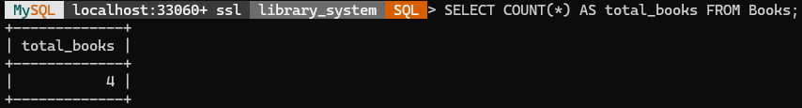

1. **Calculate Total Fines**

* Calculate the total fines for a specific patron.

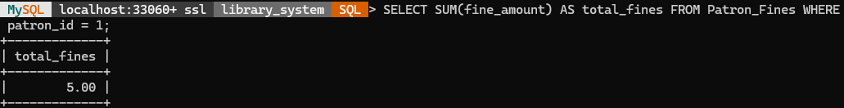

1. **Select Books by Genre**

* Retrieve all books that belong to a specific genre.

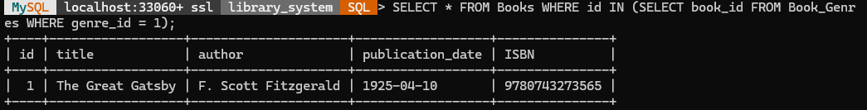

1. **Filter Records**

* Retrieve books published after the year 2000.

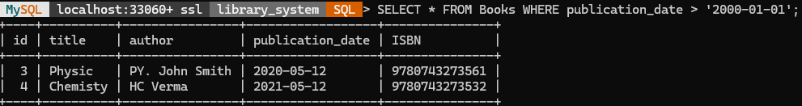

1. **FINAL GOAL OF THIS PROJECT**

The main goal of the Library Management System (LMS) project is to create a comprehensive and efficient software solution that simplifies the management of library resources and services. The LMS seeks to enhance the user experience for both librarians and patrons by automating routine tasks, improving accessibility, and offering valuable insights through reporting and analytics.

By accomplishing these objectives, the LMS project aims to develop a modern, efficient, and user-friendly system that improves library functionality and service quality. Ultimately, this will result in higher patron satisfaction, better resource management, and more effective library operations.